Data Validation using SQL

**BANK LOAN REPORT | SUMMARY**

**KPI - TOTAL LOAN APPLICATIONS**

1. --Total No.of Loan Applications

Select COUNT(ID) as 'Total_Loan_Applications' from bank_loan_data;



1. --MTD Total Loan Applications

Select COUNT(ID) as 'MTD_Total_Loan_Applications' from bank_loan_data

where MONTH(issue_date) = 12 and YEAR(issue_date) = 2021;

-- Latest month available in the dataset is December and the Month number for December is "12"

-- MTD(Month to Date) means the period starting from the beginning of the current month up until the present date, not including the current date.

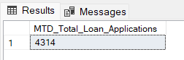

1. –- Previous MTD Total Loan Applications

Select COUNT(ID) as 'PMTD_Total_Loan_Applications' from bank_loan_data

where MONTH(issue_date) = 11 and YEAR(issue_date) = 2021;

-- Last month for december is november and the Month number for November is "11"

--MoM(Month on Month) is an expression used to compare data from one month to the previous month. Here we are calculating only previous month data and not the comparison

-- Formula for MoM is (MTD-PMTD)/PMTD = (4314-4035)/4035 =

0.069 * 100 = 6.9 increase in loans

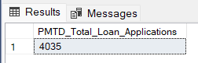

**KPI - TOTAL FUNDED AMOUNT**

1. Funded amount is Loan Amount in our dataset

--Total Funded Amount

Select Sum(loan_amount) as 'Total_Funded_Amount' from bank_loan_data;

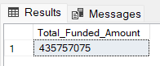

1. --MTD Total Funded Amount

Select Sum(loan_amount) as 'MTD_Total_Funded_Amount' from bank_loan_data

where MONTH(issue_date) = 12 and YEAR(issue_date) = 2021;

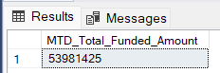

1. --Previous MTD Total Funded Amount

Select Sum(loan_amount) as 'PMTD_Total_Funded_Amount' from bank_loan_data

where MONTH(issue_date) = 11 and YEAR(issue_date) = 2021;

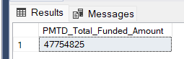

**KPI - TOTAL AMOUNT RECEIVED**

1. --Total_Amount_Received

Amount received is total_payment in our dataset

Select Sum(total_payment) as 'Total_Amount_Received' from bank_loan_data;

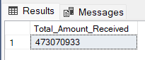

1. --MTD Total_Amount_Received

Select Sum(total_payment) as 'MTD_Total_Amount_Received' from bank_loan_data

where MONTH(issue_date) = 12 and YEAR(issue_date) = 2021;



1. --Previous MTD Total Amount Received

Select Sum(total_payment) as 'PMTD_Total_Amount_Received' from bank_loan_data

where MONTH(issue_date) = 11 and YEAR(issue_date) = 2021;

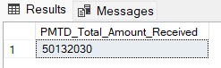

**KPI – AVERAGE INTEREST RATE**

1. Average_Interest_Rate

Select ROUND(avg(int_rate),4) * 100 as 'Average_Interest_Rate' from bank_loan_data;

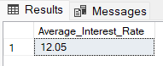

1. MTD Average_Interest_Rate

Select ROUND(avg(int_rate),4) * 100 as 'MTD_Average_Interest_Rate' from bank_loan_data

where MONTH(issue_date) = 12 and YEAR(issue_date) = 2021;

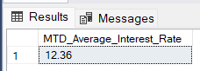

1. Previous MTD Average_Interest_Rate

Select ROUND(avg(int_rate),4) * 100 as 'PMTD_Average_Interest_Rate' from bank_loan_data

where MONTH(issue_date) = 11 and YEAR(issue_date) = 2021;

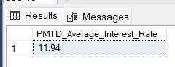

12.36 > 11.94 IR, so bank is having profit

**KPI – AVERAGE DEBT-TO-INTEREST (DTI) RATIO**

1. Avg Debt-to-Income Ratio(DTI)

Select ROUND(avg(dti),4) * 100 as 'Avg_DTI' from bank_loan_data;

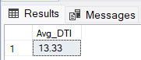

1. MTD Avg Debt-to-Income Ratio(DTI)

Range of DTI between 30-35% is considered good for most of the banks

Select ROUND(avg(dti),4) * 100 as 'MTD_Avg_DTI' from bank_loan_data

where MONTH(issue_date) = 12 and YEAR(issue_date) = 2021;

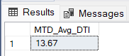

1. PMTD Avg Debt-to-Income Ratio(DTI)

Select ROUND(avg(dti),4) * 100 as 'PMTD_Avg_DTI' from bank_loan_data

where MONTH(issue_date) = 11 and YEAR(issue_date) = 2021;

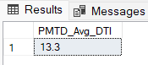

**GOOD LOAN vs BAD LOAN**

-- GOOD Loan vs BAD Loan

Select loan_status from bank_loan_data;

Select DISTINCT(loan_status) from bank_loan_data;

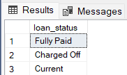

-- Good loan = "Fully Paid" & "Current", Bad loan = "Charged Off"

**KPI – GOOD LOAN Calculations**

1. Good Loan Application %

Select ROUND((COUNT(CASE WHEN loan_status = 'Fully Paid' Or loan_status = 'Current' THEN id END) * 100.0)

/

(COUNT(id)),2) AS 'Good_loan_Percentage' from bank_loan_data;

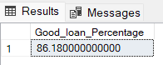

1. Good Loan Applications

select Count(id) as 'Good_Loan_Applications' from bank_loan_data

where loan_status = 'Fully Paid' Or loan_status = 'Current';

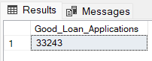

1. Good Loan Funded Amount

select SUM(loan_amount) as 'Good_Loan_Funded_Amount' from bank_loan_data

Where loan_status = 'Fully Paid' Or loan_status = 'Current';

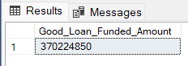

1. Good Loan Total Received Amount

select sum(total_payment) as 'Good_Loan_Received_Amount' from bank_loan_data

Where loan_status = 'Fully Paid' Or loan_status = 'Current';

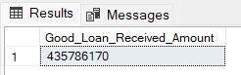

**KPI – BAD LOAN Calculations**

1. Bad Loan Application %

Select ROUND((COUNT(CASE WHEN loan_status = 'Charged Off' THEN id END) * 100.0)

/

(COUNT(id)),2) AS 'Bad_loan_Percentage' from bank_loan_data;

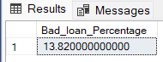

1. Bad Loan Applications

select Count(id) as 'Bad_Loan_Applications' from bank_loan_data

where loan_status = 'Charged Off';

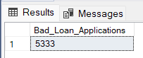

1. Bad Loan Funded Amount

select SUM(loan_amount) as 'Bad_Loan_Funded_Amount' from bank_loan_data

Where loan_status = 'Charged Off';

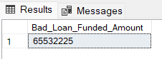

1. Bad Loan Total Received Amount

select sum(total_payment) as 'Bad_Loan_Received_Amount' from bank_loan_data

Where loan_status = 'Charged Off';

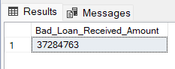

**GRID VIEW**

**KPI – Loan Status**

1. Loan Status Grid View

select loan_status,

COUNT(id) as 'Loan_Count',

SUM(total_payment) as 'Total_Received_Amount',

SUM(loan_amount) as 'Total_Funded_Amount' ,

ROUND(AVG(int_rate*100),2) as 'Avg_Interest_rate',

ROUND(AVG(dti*100),2) as 'Avg_DTI'

from bank_loan_data

group by loan_status;

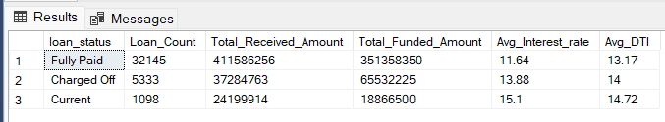

1. MTD Loan Status Grid View

select loan_status,

SUM(loan_amount) as 'MTD_Total_Funded_Amount' ,

SUM(total_payment) as 'MTD_Total_Received_Amount'

from bank_loan_data

where MONTH(issue_date) = 12 and YEAR(issue_date) = 2021

group by loan_status;

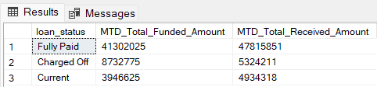

**BANK LOAN REPORT | OVERVIEW**

**KPI Metrics to be shown:**

**'Total Loan Applications',**

**'Total Funded Amount',**

**'Total Amount Received**

1. Chart - Monthly trends by Issue Date

SELECT

MONTH(issue_date) AS 'Month_Number',

DATENAME(MONTH, issue_date) AS 'Month_name',

COUNT(id) AS 'Total_Loan_Applications',

SUM(loan_amount) AS 'Total_Funded_Amount',

SUM(total_payment) AS 'Total_Amount_Received'

FROM bank_loan_data

GROUP BY MONTH(issue_date), DATENAME(MONTH, issue_date)

ORDER BY MONTH(issue_date);

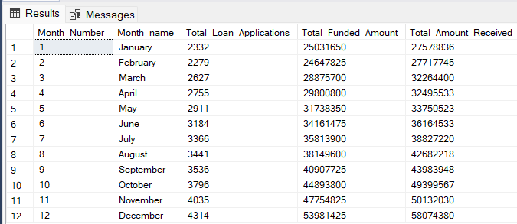

1. Chart - **Regional Analysis by State**

select address_state as 'State',

COUNT(id) AS 'Total_Loan_Applications',

SUM(loan_amount) AS 'Total_Funded_Amount',

SUM(total_payment) AS 'Total_Amount_Received'

from bank_loan_data

group by address_state

order by address_state;

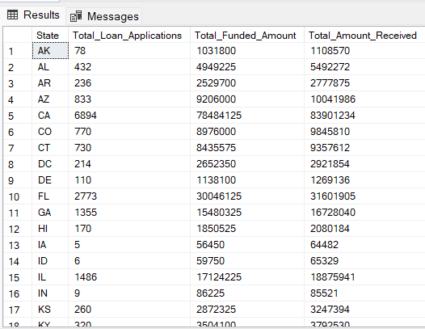

1. **Chart - Loan Term Analysis**

select DISTINCT(term) from bank_loan_data;

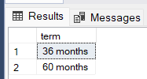

select term as 'Term',

COUNT(id) AS 'Total_Loan_Applications',

SUM(loan_amount) AS 'Total_Funded_Amount',

SUM(total_payment) AS 'Total_Amount_Received'

from bank_loan_data

group by term

order by term;

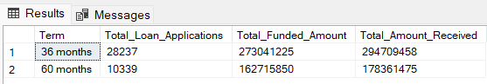

1. **Chart - Employee Length Analysis**

select emp_length as 'Employee Length',

COUNT(id) AS 'Total_Loan_Applications',

SUM(loan_amount) AS 'Total_Funded_Amount',

SUM(total_payment) AS 'Total_Amount_Received'

from bank_loan_data

group by emp_length

order by emp_length;

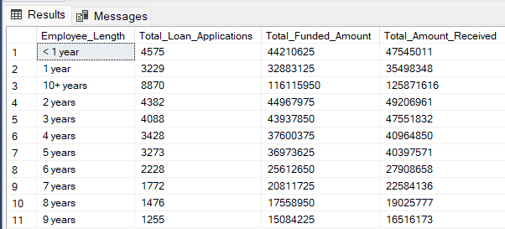

1. Chart - **Loan Purpose Breakdown**

select DISTINCT(purpose) from bank_loan_data;

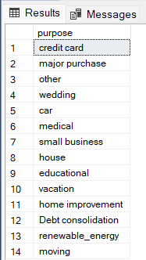

select purpose as 'Loan_Purpose',

COUNT(id) AS 'Total_Loan_Applications',

SUM(loan_amount) AS 'Total_Funded_Amount',

SUM(total_payment) AS 'Total_Amount_Received'

from bank_loan_data

group by purpose

order by COUNT(id) desc;

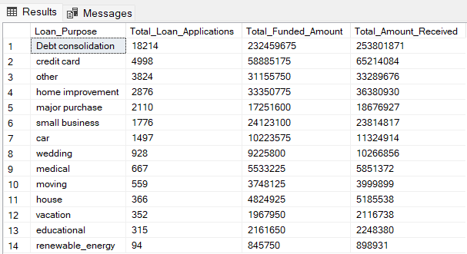

1. **Chart - Home Ownership Analysis**

select DISTINCT(home_ownership) from bank_loan_data;

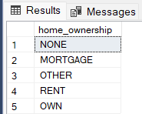

select home_ownership as 'Home_Ownership',

COUNT(id) AS 'Total_Loan_Applications',

SUM(loan_amount) AS 'Total_Funded_Amount',

SUM(total_payment) AS 'Total_Amount_Received'

from bank_loan_data

group by home_ownership

order by COUNT(id) desc;

